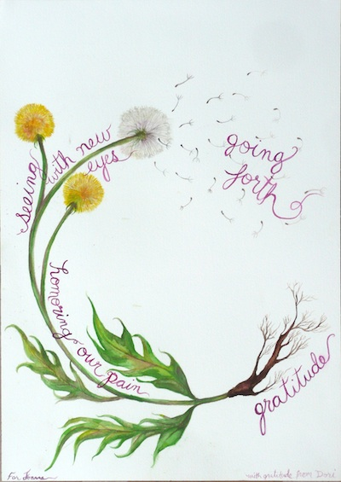
ACTIVE HOPE
An Introduction to the
Work That Reconnects

Saturday, May 20, 2017
9:30 am – 4:30 pm

We live in an extraordinary moment on Earth. As we witness unprecedented destruction of ecological, biological, and social systems, we can feel overwhelmed by anger, fear and other difficult emotions. How can we remain resilient, creative, and empowered to act for the healing of our irreplaceable world?

The Work That Reconnects, developed by teacher/activist Joanna Macy and others, draws on deep ecology, systems theory, and engaged Buddhism. Practices include group meditations, ritual, conversation in pairs, dance, and song. We will explore spiritual, emotional and intellectual aspects of envisioning and creating a life-sustaining society.

WHAT to expect from the workshop?
- Practices in love and gratitude
- Acknowledgement of our pain for the world
- Sources of hope and insight
- Commitment to change, healing, and action
- Tools to take into your life

WHO: The workshop will be facilitated by members of the Boston-area Work That Reconnects Community of Practice

WHERE: Cambridge Cohousing 175 Richdale Ave (near Porter Square), Cambridge Mass.

SUGGESTED DONATION: $5-$20

TO REGISTER: Go to https://actionnetwork.org/events/active-hope-an-introduction-to-the-work-that-reconnects-2/ Please register early - space will be limited

FOR MORE INFORMATION:
- On the workshop: WtR@houserock.org or Patti Muldoon at 781-648-1019
- On the Work That Reconnects: www.workthatreconnects.org

